|  |
| --- |
| NAMI College(University of Northampton) |
| Report On CSY1018-Assign1 |
| Web Development 1st Assignment |

|  |
| --- |
| Student’s Name:Anish Pithakote  Student ID:16441457  3/8/2017 |

|  |
| --- |
| CONTENTS page no   1. Introduction ………………………………………………………2 2. Research 3. Analysis 4. Finding/Planning 5. The Logo………………………………………………………….2 6. The Navigation Bar……………………………………………….3 7. The Footer………………………………………………………...3 8. Wire framing 9. Progressing of the work 10. The Pages…………………………………………………………4 11. The index page………………………………………………..4 12. The Bio page………………………………………………….5 13. The form page………………………………………………...6 14. The CV page………………………………………………….7 15. The responsiveness of the pages……………………………...8-10 16. Conclusion………………………………………………………..10 17. References………………………………………………………..10 |

# 1)INTRODUCTION

# The assignment assisted us to make a simple personal portfolio website using just HTML5 and CSS.

# It was instructed to insert the students’ names and the their respective UN I.Ds with them as a comment on all codes and files with the assignment folder zipped containing the subfolders like the following as instructed to us:

csy1018-assign1/ All html files (.html)

csy1018-assign1/images All website image files (.gif .jpg)

csy1018-assign1/css All css files (.css)

csy1018-assign1/README.md or README.txt

We were instructed to deliver four web pages including a homepage, a bio page, a contact page and a “CV” page having the following requirements:

cv page – The cv page should include the name, the education , relevant coursework , professional experience , skills and the activities which are related to my field of study .

contact page – This page should include a form .

Index page – This page should represent the student’s personal home page and should be accessible from the link “Github link” of that student.

Bio page: This page should include a short biography of that particular student.

As there are some requirements to be followed and should be included in the web pages, there are some restrictions too. Some of them are as follows:

Tables cannot be used to positioning.

Styling elements in the html code page should not be used.

Inline styles are prohibited.

Absolute URLs cannot be used.

Lorem Ipsum or any kind of filler texts cannot be used.

Frameworks and JavaScript and jQuery cannot be used.

These are some of the requirements and prohibitions which is to be followed by the students.

# 2) RESEARCH

I knew what I had to do, but I did not have a slightest of idea of how would I start it. I had thought of making a simple website. So, the beginning of the creation of the webpages had to be done by doing some research work. I needed to look at some of the examples or the templates of a simple website. I did not even had a design so I went online and searched the internet and found some websites which were pretty interesting.

Here are some of the screenshots of the web pages where I looked up on the internet for ideas them :

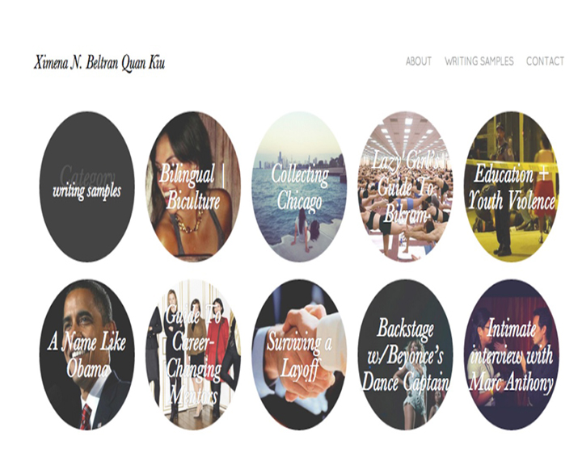

Fig : Screenshot of the webpage made be Ximena N.Beltran Quan Kw

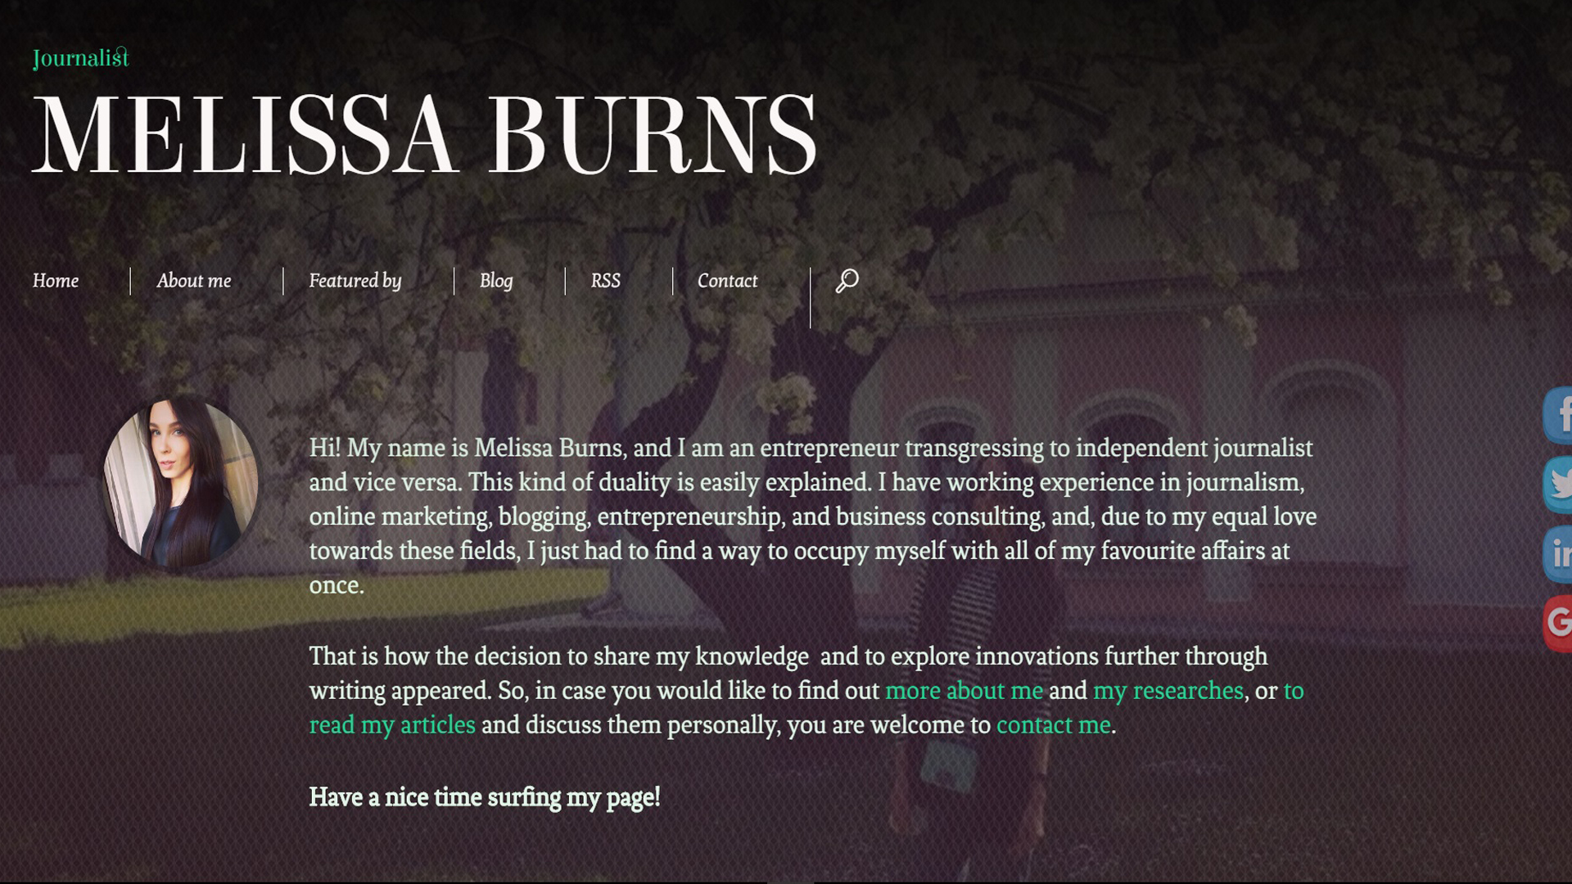

Fig: The screenshot of the webpage made by Melissa Burns.

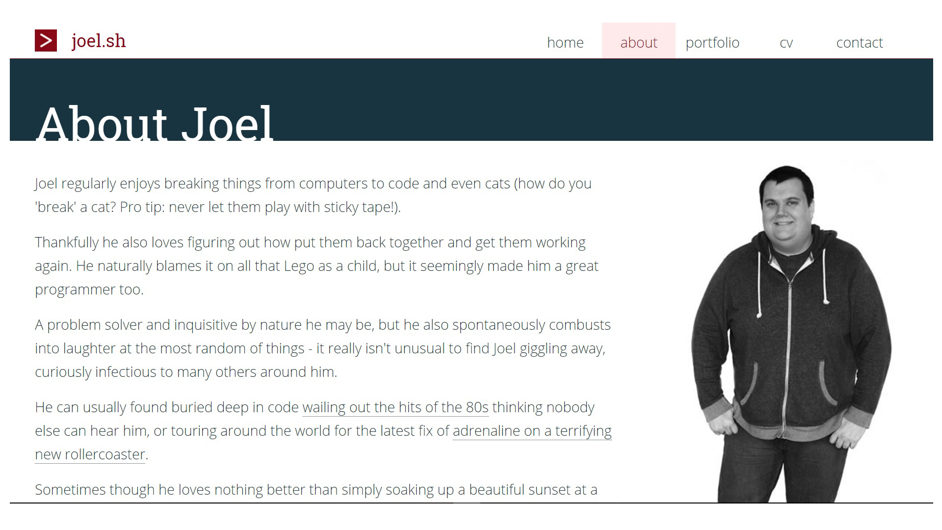

Fig: The screenshot of the webpage of Joel Stanford.

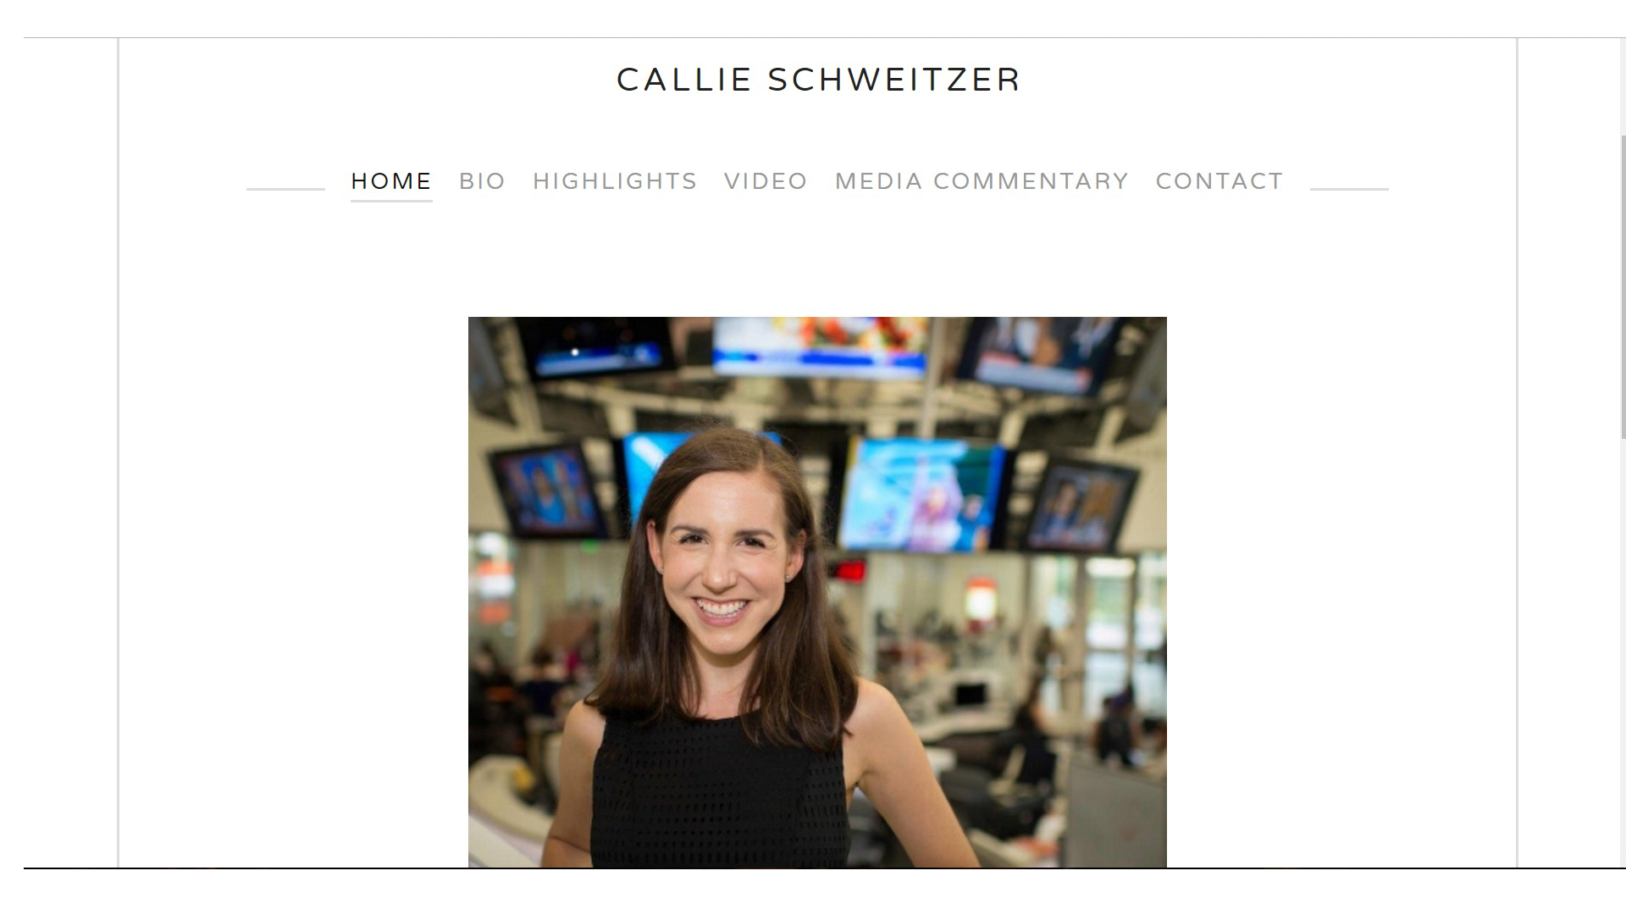

Fig : The screenshot of the webpage made by Callie Schweitzer.

# 3) ANALYSIS

Analyzing, the above webpages that I visited , have some good ideas and have some really cool features which I really would like to include in my webpages.

All of the pages are quite simple as I want my webpages would like to be. But there are still some pros and cons of those pages.

Lets look at the pros and cons of the pages individually.

1. Ximena N.Beltran Quan Kw’s Page:

Pros:

1. The page is quite user friendly as it has a lot of interactive images on it.
2. The page itself is so simple that ht user doesn’t find anything confusing or complicated.

Cons:

1. Almost all of the pages look the same.
2. Melissa Burns.’ Page:

This page has got six links linked in it’s webpage. They are home,about me ,featured by, blog , rss and contact.

Pros:

1. The page is quite easy to navigate around.
2. The page is simple design .
3. Cool looking javascripts have been used making the webpage attractive.

CONS:

1. The fonts used are not so user friendly as it makes the website a little weird looking and makes it lose it’s charm.
2. There is too much gap between the navigation bar and the main content making look a little out of place.
3. When clicked on “featured by” butto, nine company logos appear which are linked to their respective websites.

These logos are kept do close to each other with nothing to specify each logo’s border which makes the user difficult to see where they have clicked .

These logos are not assembled in quite a pleasing look.

1. Different fonts of different sizes have been used in multiple sections of the webpages.

It makes the webpage look kind of un pleasing to look at and the user might feel something has changed and has made the webpage not good but they cannot figure out exactly what that is.

1. RSS page look as if every piece of information has been put in a small box without assembling those information making it look ugly.
2. Joel Stanford’s Page:

Pros:

1. The webpage is user friendly .
2. Very easy to navigate.
3. Interactive buttons.
4. The smooth movement of fixed navigation bar makes the impression of the website even better.
5. The colour combination of the webpage is quite pleasing and has fitted perfectly to the page.
6. The map feature has been added to the bottom of the page making it a little bit attractive and making the user find out where he os at the moment .

Cons:

1. Only little part of the information is provided about Joel.
2. The logo is very attractive but he should have made it linked to the home page which is not done.
3. The footer has quite congested with all the items mashed together.
4. Callie Schweitzer’s Page:

Pros:

1. When the page’s window is shrunk down, the the navigation bar disappears and instead of that , a “MENU” appears which on clicked shows the navigation bar items aligned in a column .
2. The page looks clean because of the color choice as there is not much color used . The only color used is white for the background and black for the font.
3. User friendly hover properties have been used which makes easy for the user to select the particular button.

CONS:

1. The one thing I didn’t like at the first when I saw the page was the font type, and the adjustment of the font contents. They have not been arranged in a way that would make the page attractive but creates a type of “Ugliness” in the page.
2. The spacing between the contents and the outer line and the screen is too much making it seem like too much of space is left out .
3. The content in the “Contact ” page could have been arranged in a way more adjustable way rather than making it seem like they have been mashed up together.

# 2) The Logo



Fig: The logo of the page

This is a custom built logo used in this project.The logo will appear in all of the webpages on the top left corner of each page and when a user clicks of the logo, it will lead them to the main home page.

3)The Navigation Bar



Fig: The Navigation Bar Menu

This menu will be present in each of the pages in the website and through it, the users can navigate around the website by selecting which page would they like to visit.

The Navigation bar consists of Home, CV, About Me and Contact Me buttons which will guide the user to the home page, the CV page, the bio page and the contact me page respectively when clicked on.

# 4)The Footer



Fig:The footer part.

This footer part consists of the social media(facebook, twitter and Youtube) sites where the user can contact me throught the social media if they wish to do so.

# 5)WIREFRAMING

## (a)THE INDEX PAGE

Started to create index page for my assignment.

I have decided to make my index page according to the following index wireframe.

I

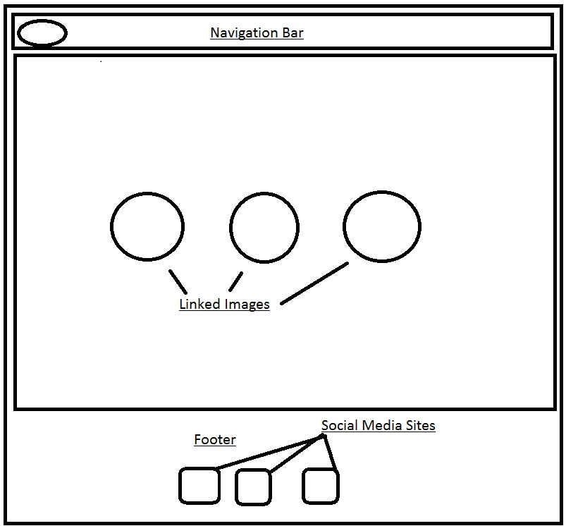

Fig(1): Wireframe for the index page.

Navigation Bar: This bar will contain Home, CV, Contact Me and About Me buttons linking to their respective pages.

Logo: My custom built logo will be placed there.

Images in Ovals: Pictures will be kept with a line describing them and linking to their respective pages.

Footer: The footer section will contain the links to my social media sites .

The web designing codes are also accompanied with their respective comments.

## (b)THE BIO (ABOUT ME) PAGE

The bio section consists of a navigation bar, a wrapper and a footer at the bottom.

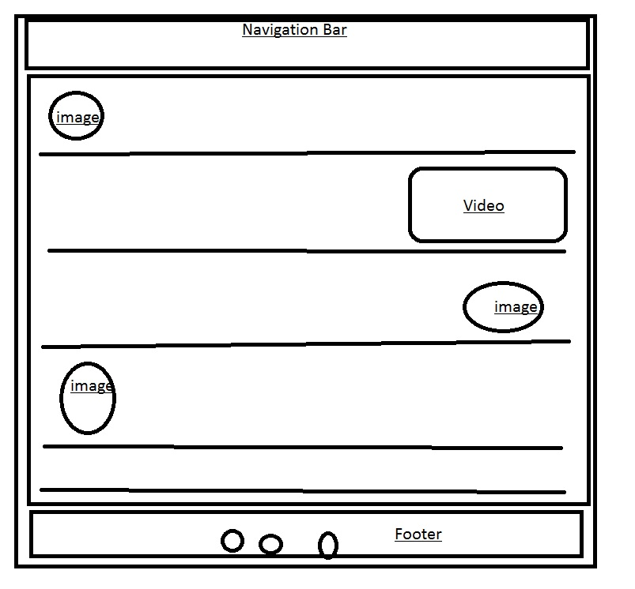

Fig(2): The basic wireframing of the Bio page.

The Navigation Bar: It consists of links to Index, CV, Bio and form pages. And a logo on the left side .

The Body (wrapper): It consists of the main content, where I have written all of my life’s details from my passions , hobbies and likes .

It has been further divided into five parts where first part tells about my bio in a brief version.  
from the second part, more contents like fitness, dancing and animals have been put up with their respective images and a video.

The footer : Consisting of icons linking to my social media sites.

After the designing of the bio page, I started working on the form page.

## (c) THE FORM PAGE

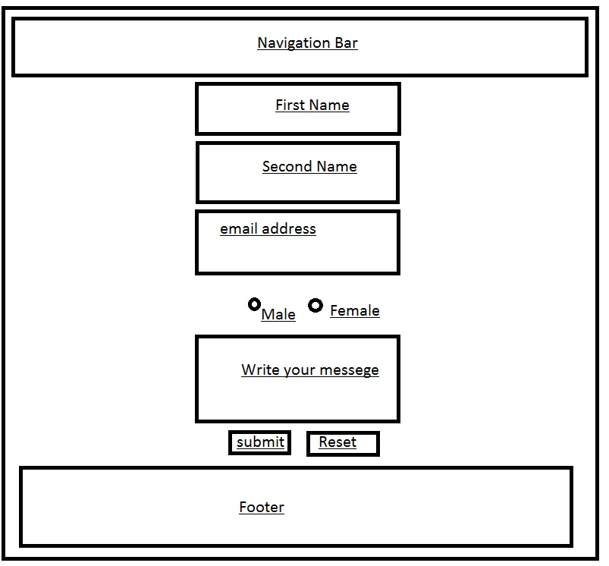

Fig(3):The basic woreframing of the form page.

The Navigation Bar: This bar consists of buttons linking to their respective pages.

The body (wrapper): This part consists of boxes, telling the people who are trying to contact me to enter

Their first name, last name , their email address , their gender and their messege .

They can click on submit to send that messege or if they want to erase everything they have written, the they can press the “reset” button.

After one and a half day of finishing three of my pages i.e index, bio and form.html pages,I made this page responsive and changed the flex direction in to columns from rows.

## (d) THE C.V PAGE

This page was made at the last i.e I made this page when I was done with the previous three pages. (index.html ,bio.html, form.html).

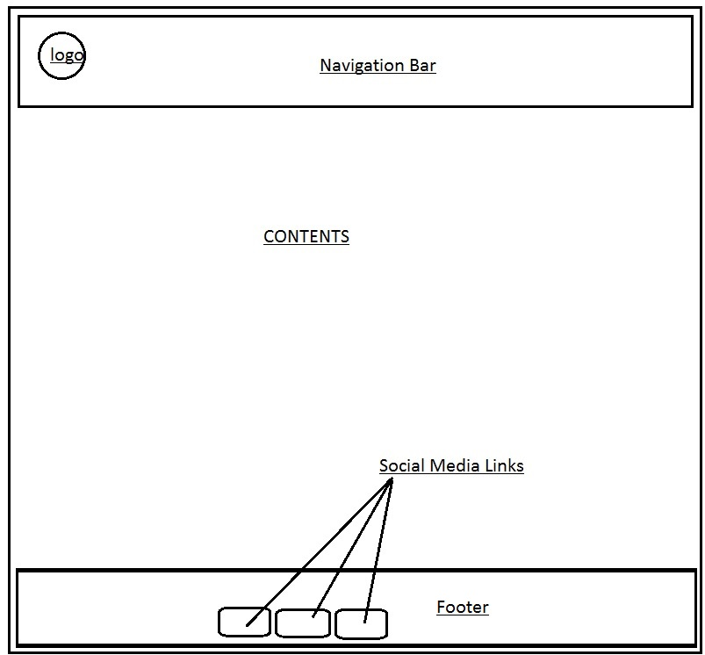

Fig (4): The wireframe of thr CV.html page.

The Navigation Bar: In this section, there are Home, CV, About Me and Contact Me buttons which are repectively linkedto their pages.

Logo : This section has a custom built logo which will be linked to the homepage.

Footer : The footer contains the Images of the social media sites which are linked to my social profiles

Contents : The contents contains the information about my experiences and skills.

(e) THE RESPONSIVENESS OF THE PAGES 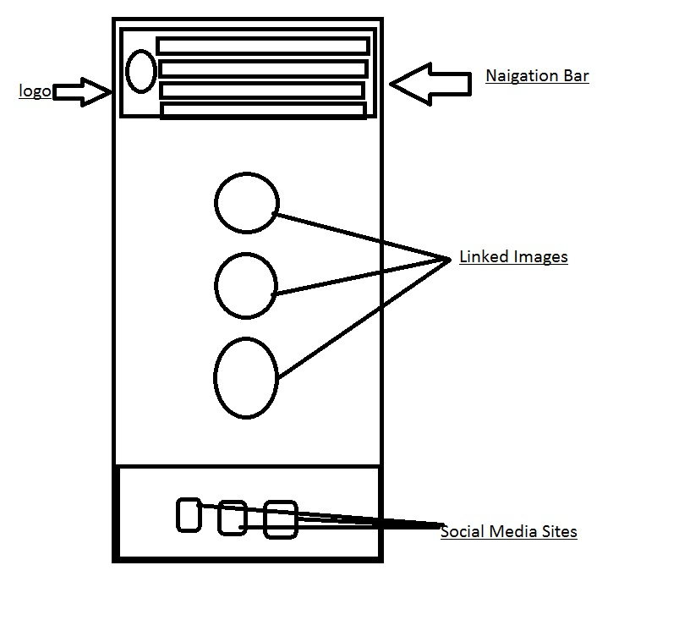 Fig(1.1)The Index page when the browser size is resized to 600px.

After a week of designing three of the pages,,  
I decided to make the index.html page responsive. The fields where the flex directions were set to “row” will now change to flex direction “column” when the window will shrink to 600px size.

The navigation bar, the pictures in the class “wrapper” will all align in a column.

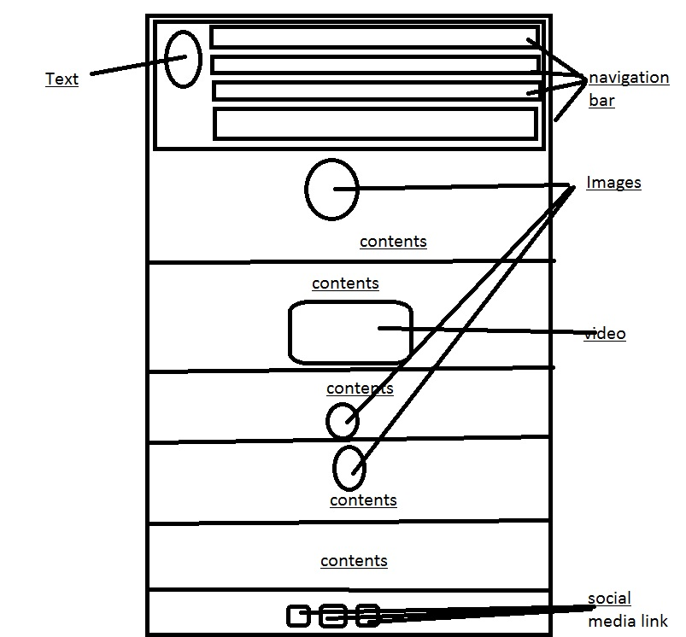

Fig (2.1) The responsive wireframe of the bio page.

The webpage was made responsive by using the “@media queries” and customizing the css file again under that condition.

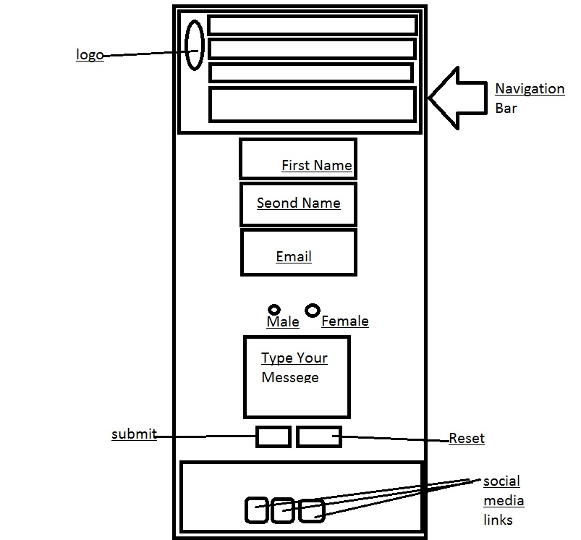

Fig(3.1):The responsie form.html page

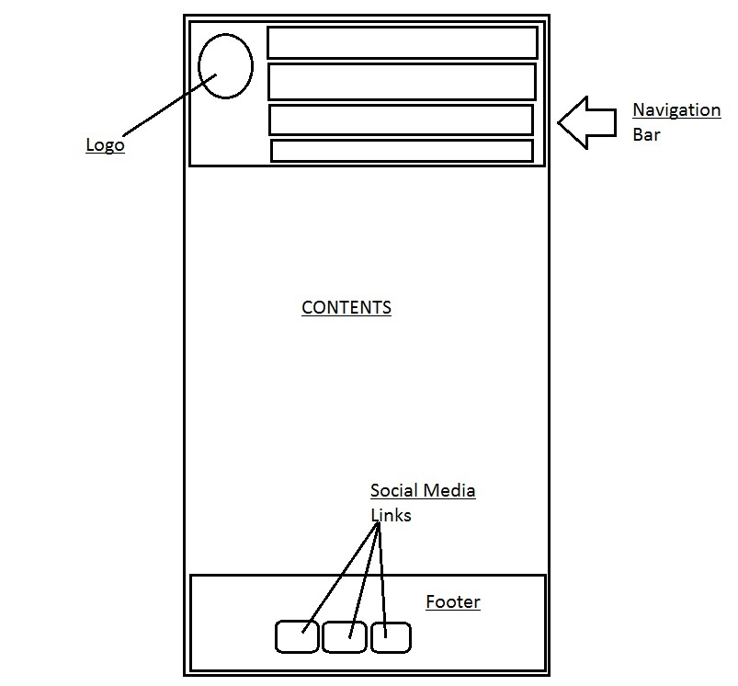

Fig(4.1): The responsive webpage of the CV.html

# 6)THE FINAL RESULT

Every webpages have been assigned with google api fonts too.

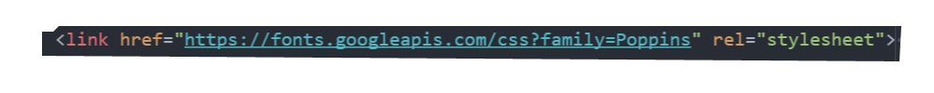

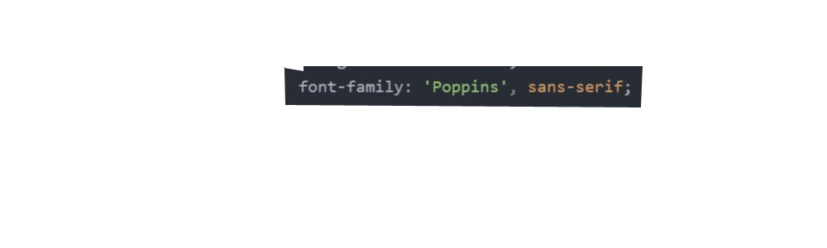

Fig: Links in the html file and the css showing the use of google api fonts

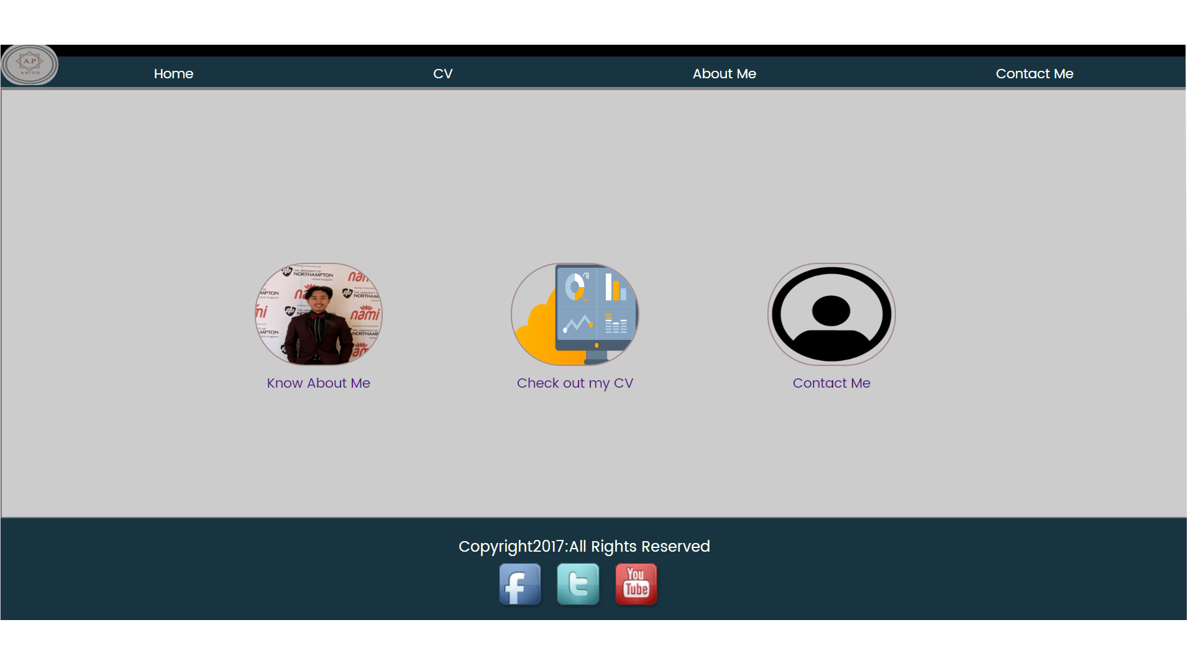

Fig:The final index page.

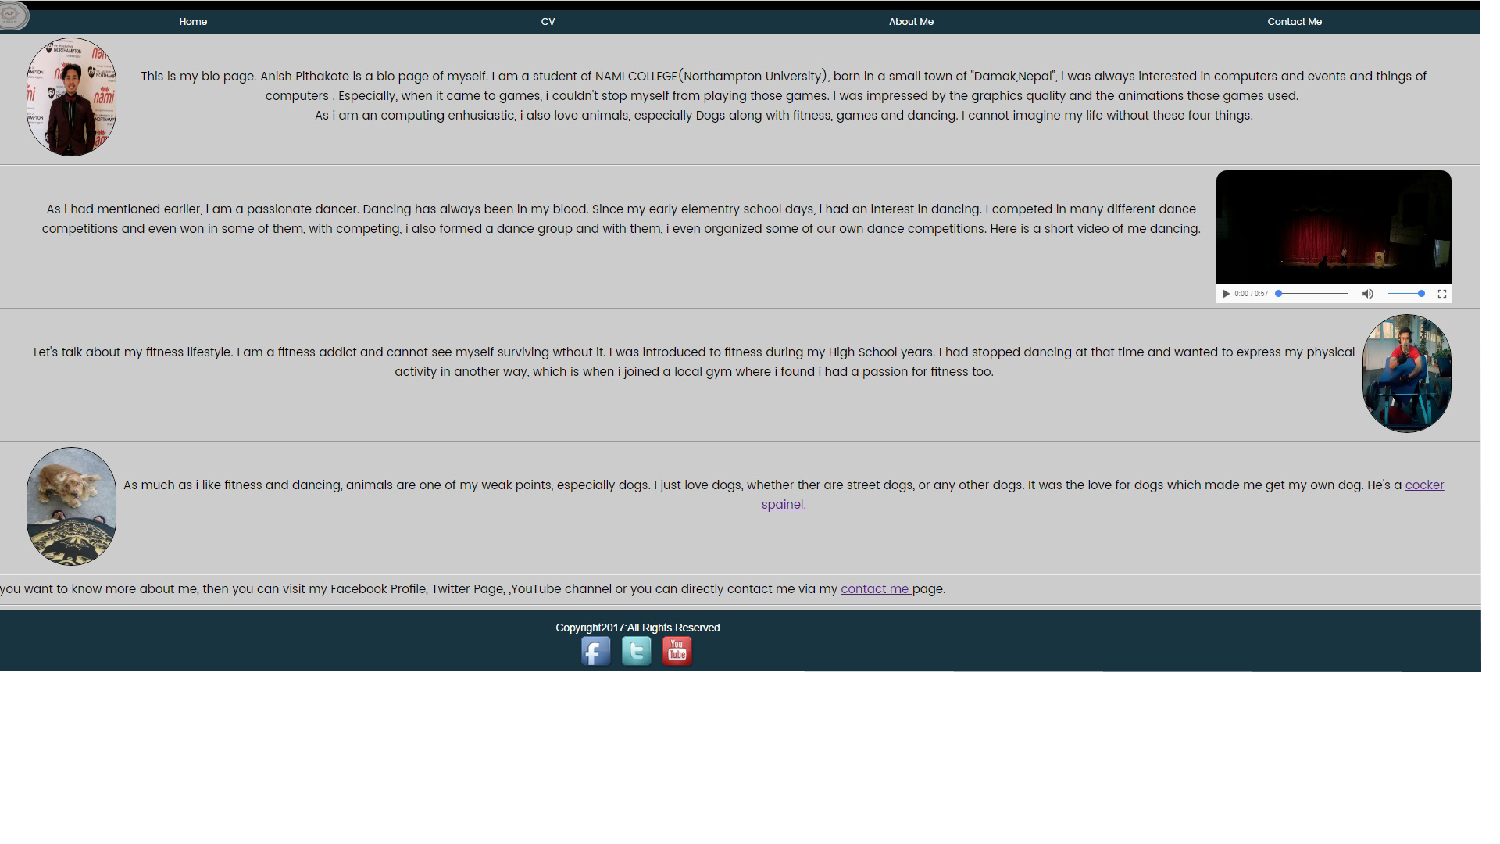

Fig: The final about me(bio) page.

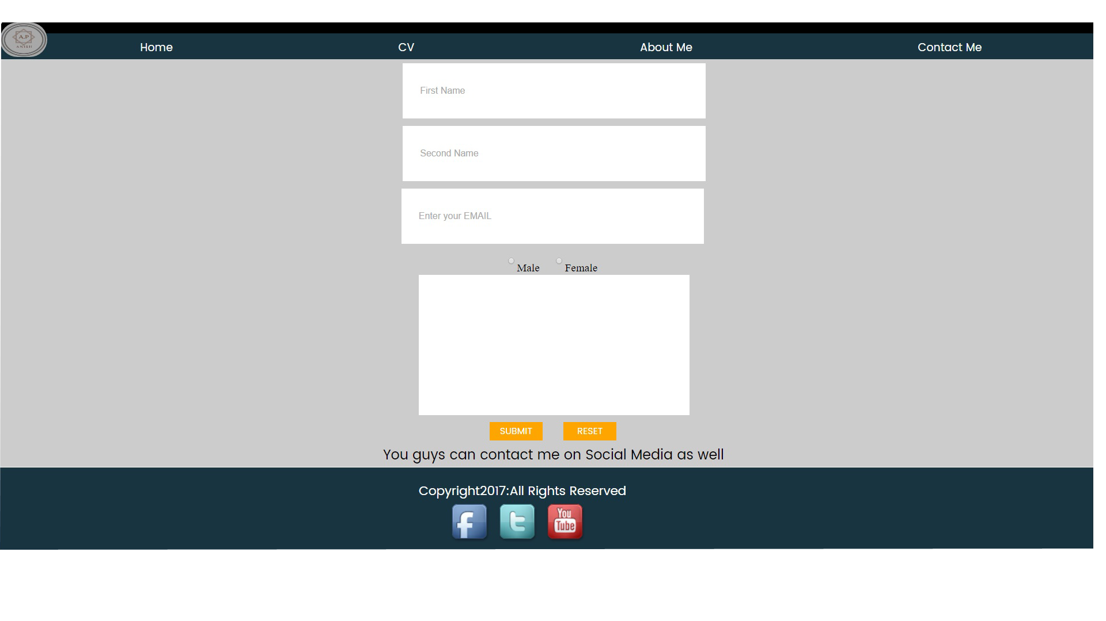

Fig: The final Contact Me(form) page.

# 7)CONCLUSION

Each of the webpages were designed at least for 3 to 4 hours per day. Each of the pages were finished designing at the 3rd to the 4th day, i.e each webpages took 3 to 4 days to finish. So approximately I spend nearly 64-70 hours just on designing the webpages.  
After I had finished designing the webpages, then I wanted to make them responsive. So , I added “@media “ to make the pages responsive if the browser window was to be shrunk to the size of 600px.

Once the browsers would be shrunk, the contents placed in the row , will appear to be in a column form.I completed making the pages responsive in 1 day working for 1 hour.

# 8)REFERENCES

Stanford.J(2015)Joel.sh.*Nile*[Online]https://joel.sh[Accessed 1st March 2017]

Kellyedmunds.co .uk

Ryanscherf.net

Rleonard.com/interactive-resume